**LAB # 03**

**RECURSION**

**OBJECTIVE**: To understand the complexities of the recursive functions and a way to reduce these complexities.

**Lab Task 1:**

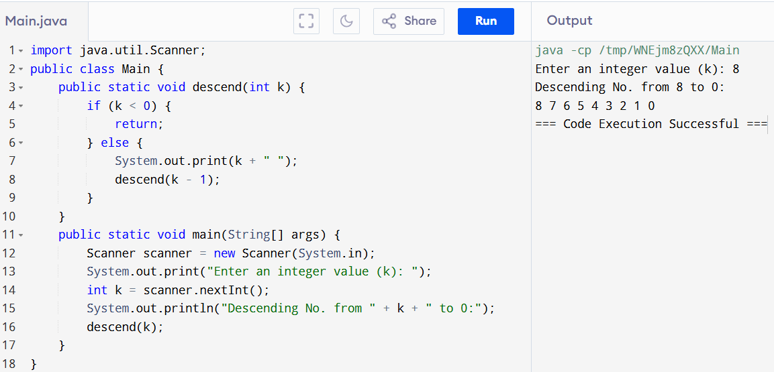

**Lab Task 2:**

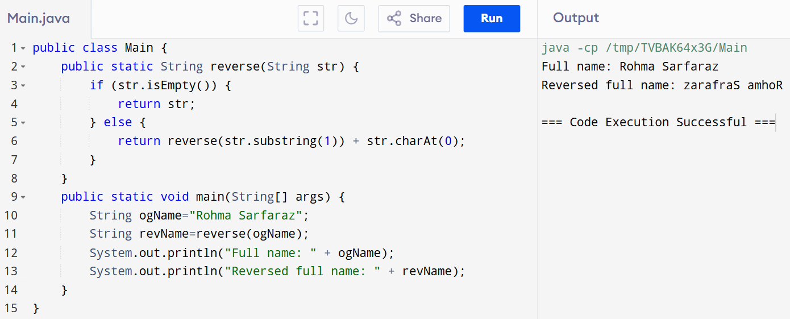

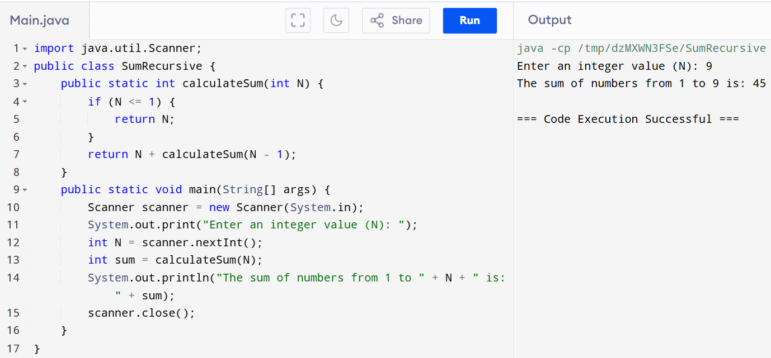Lab Task 3:

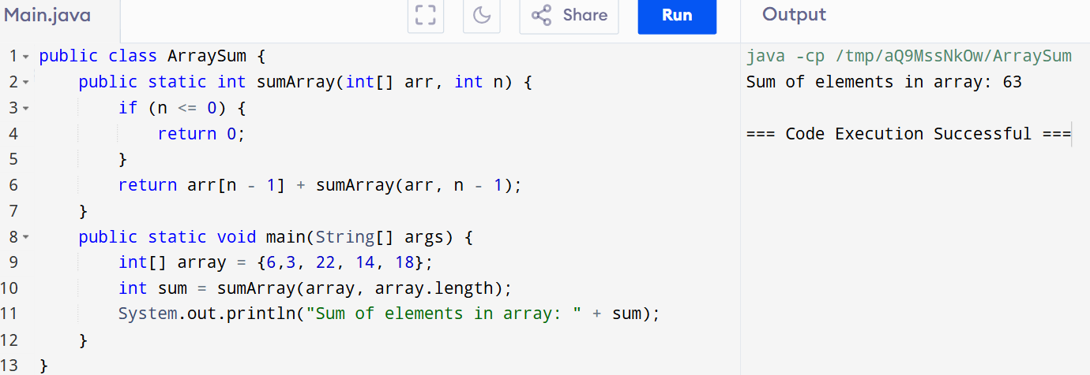Lab Task 4:

Lab Task 5:

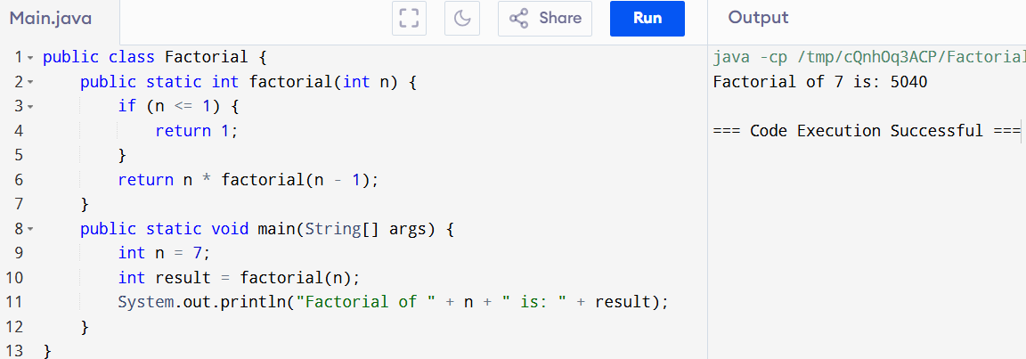

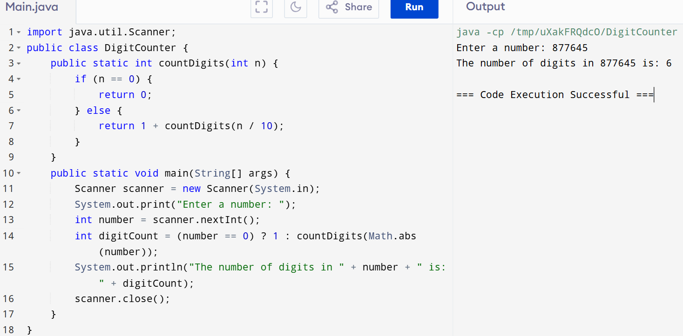Lab Task 6:

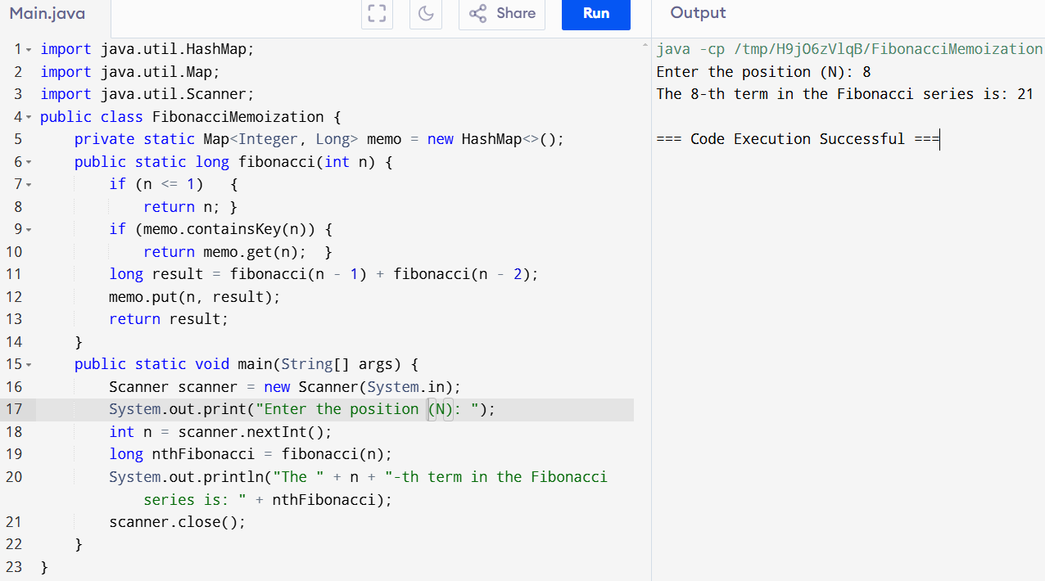Home Task 1:

Home Task 2:



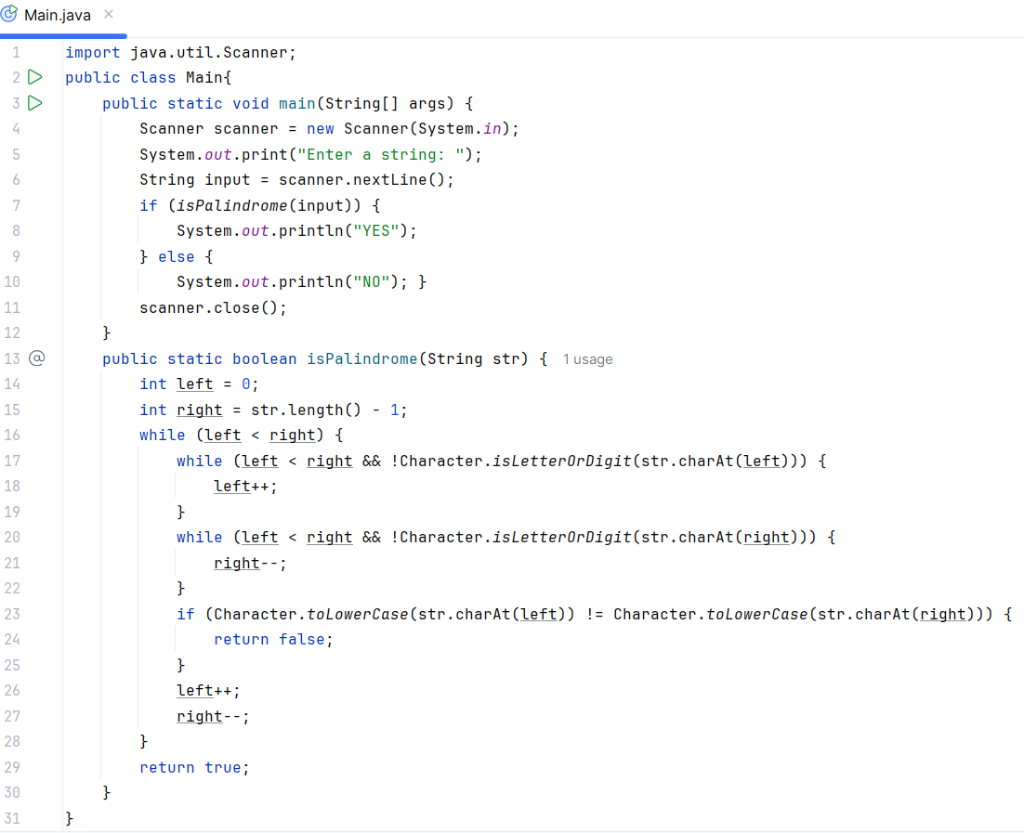Home Task 3:

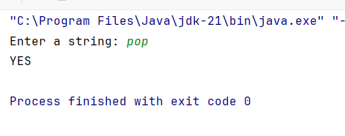Output:

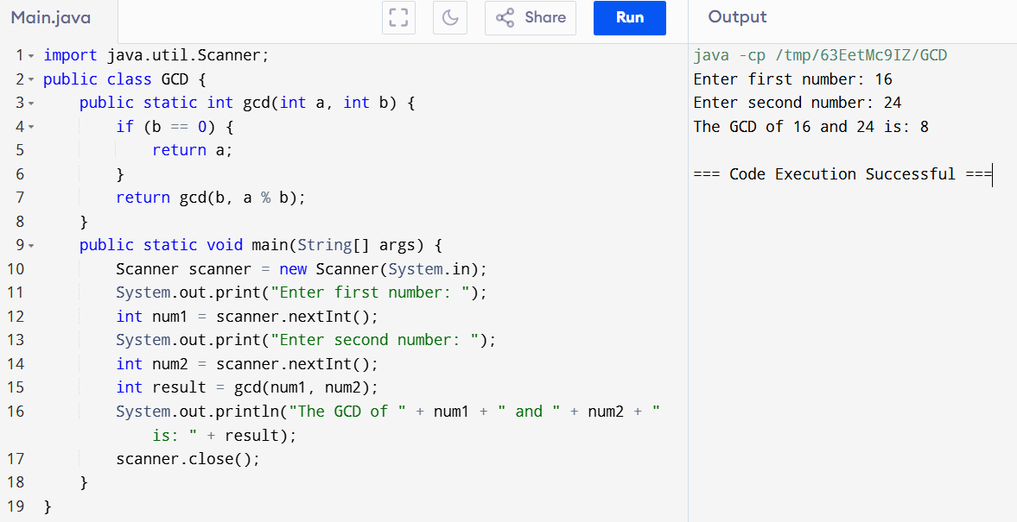Home Task 4: